Week-04-Decision Making and Looping - while, do…while and for

Week 04-01-practice session coding

Reg no : 241801291

Name : TARRUN.B

Q1)

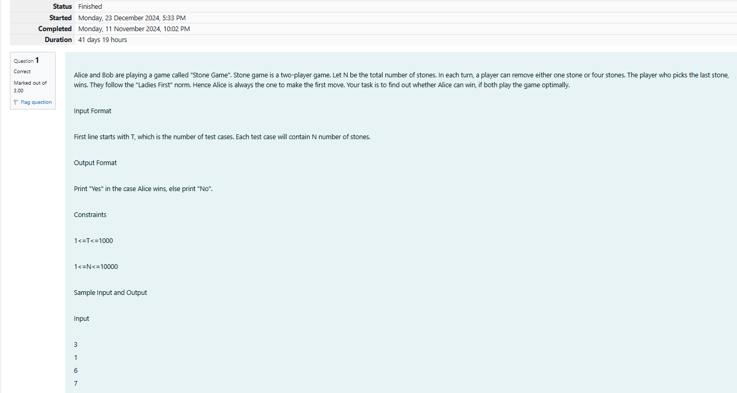

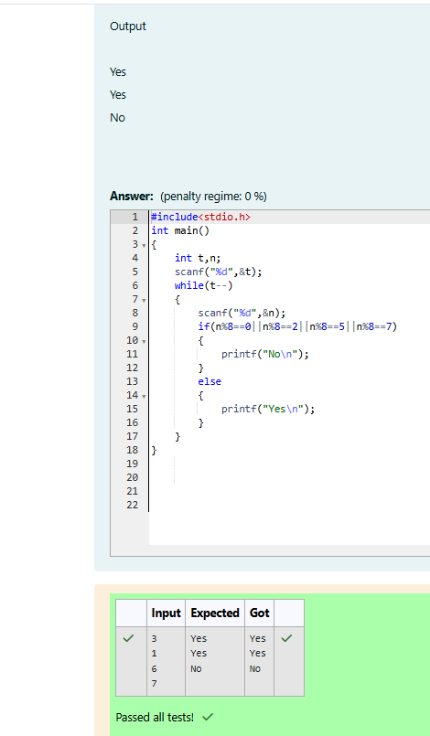

Week 04-01-practice session coding

Reg no : 241801291

Name : TARRUN.B

Q2)

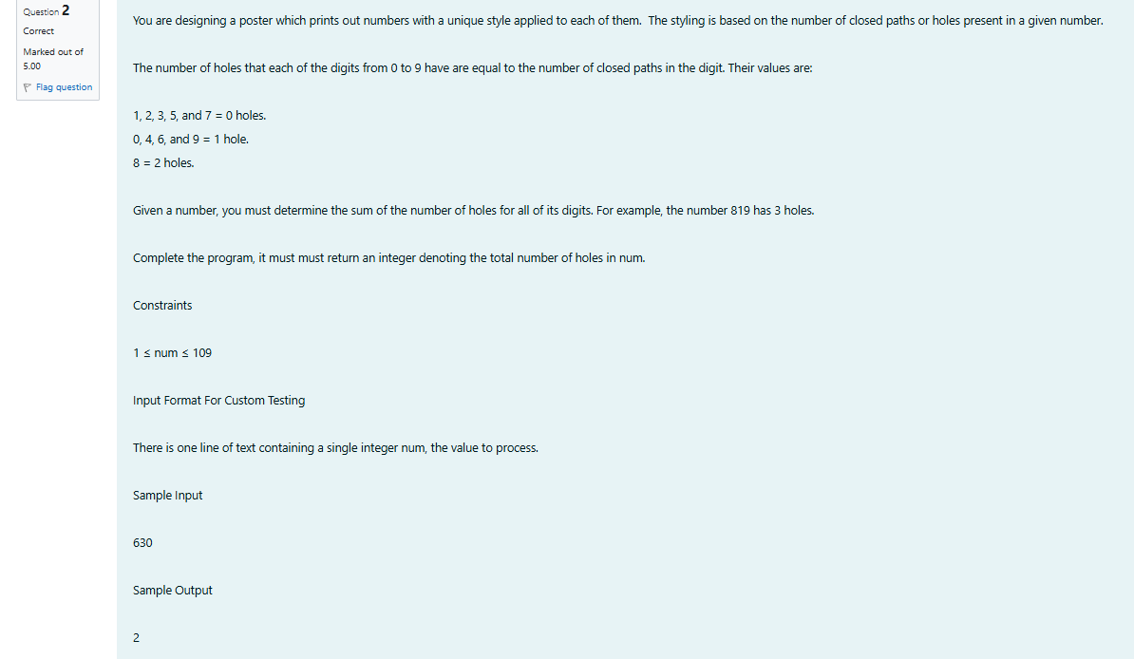

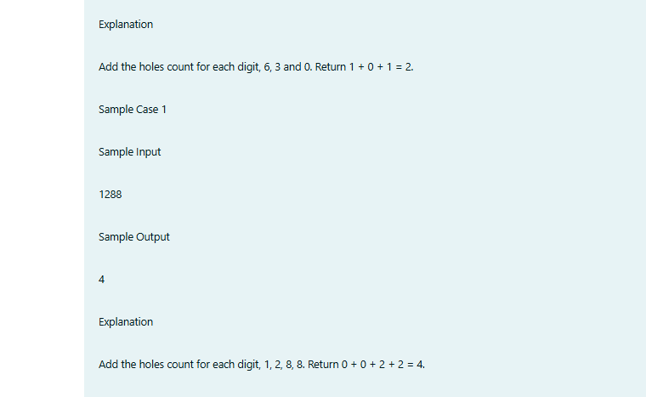

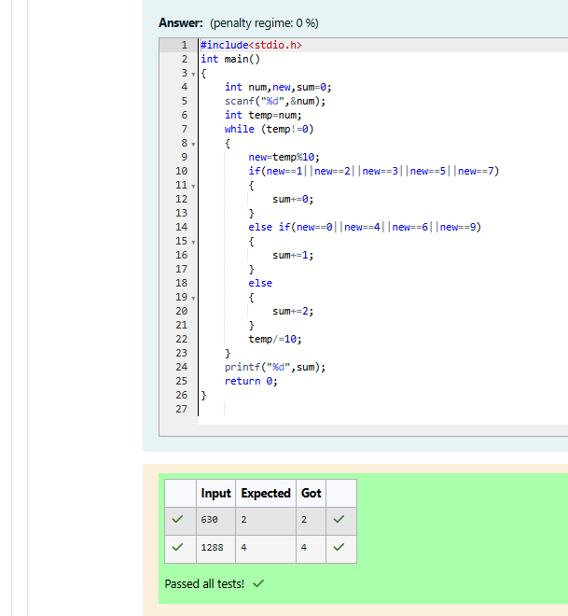

Week 04-01-practice session coding

Reg no : 241801291

Name : TARRUN.B

Q3)

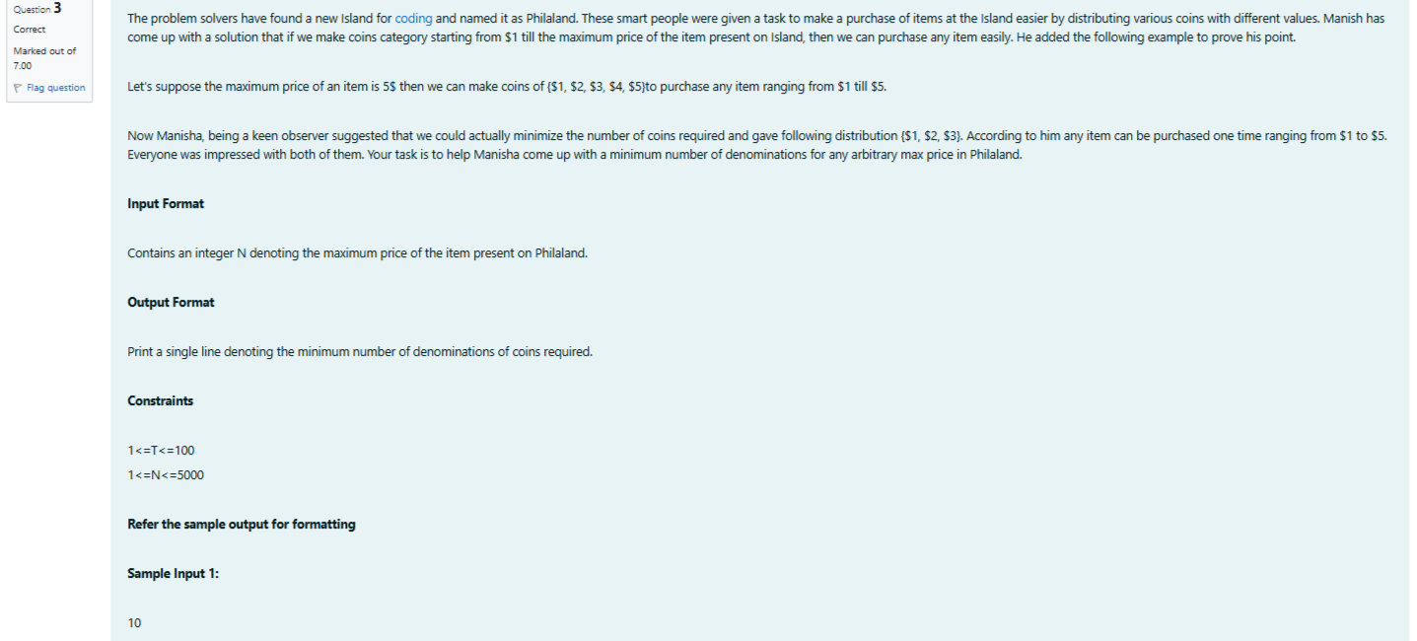

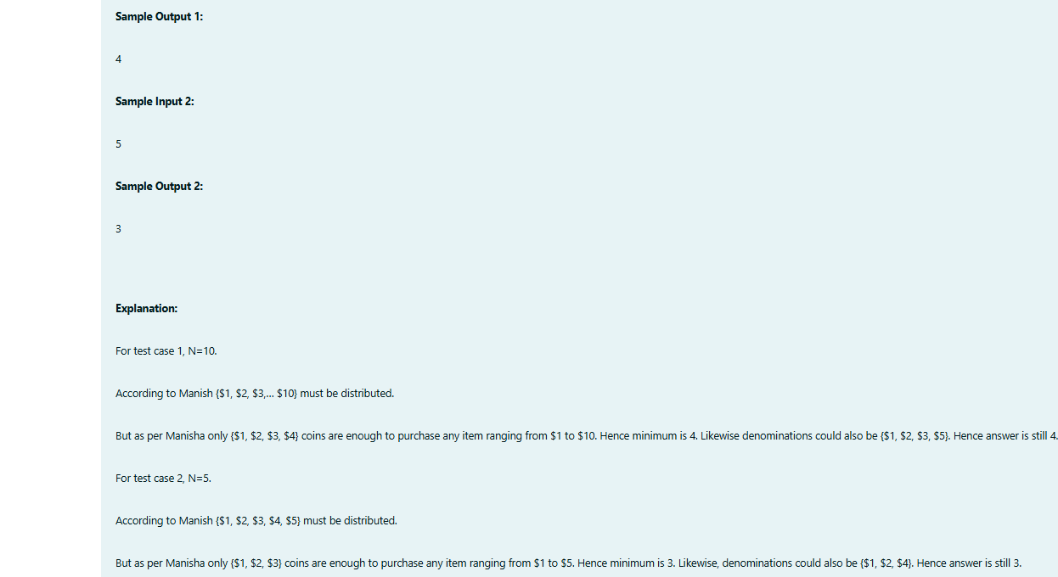

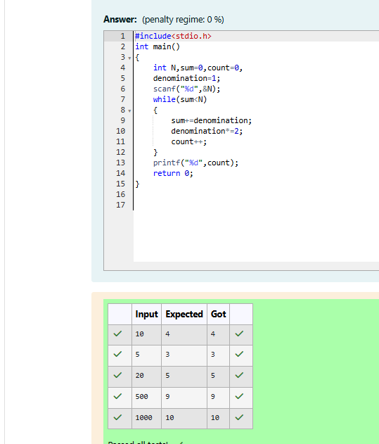

Week 04-02-practice session coding

Reg no : 241801291

Name : TARRUN.B

Q1)

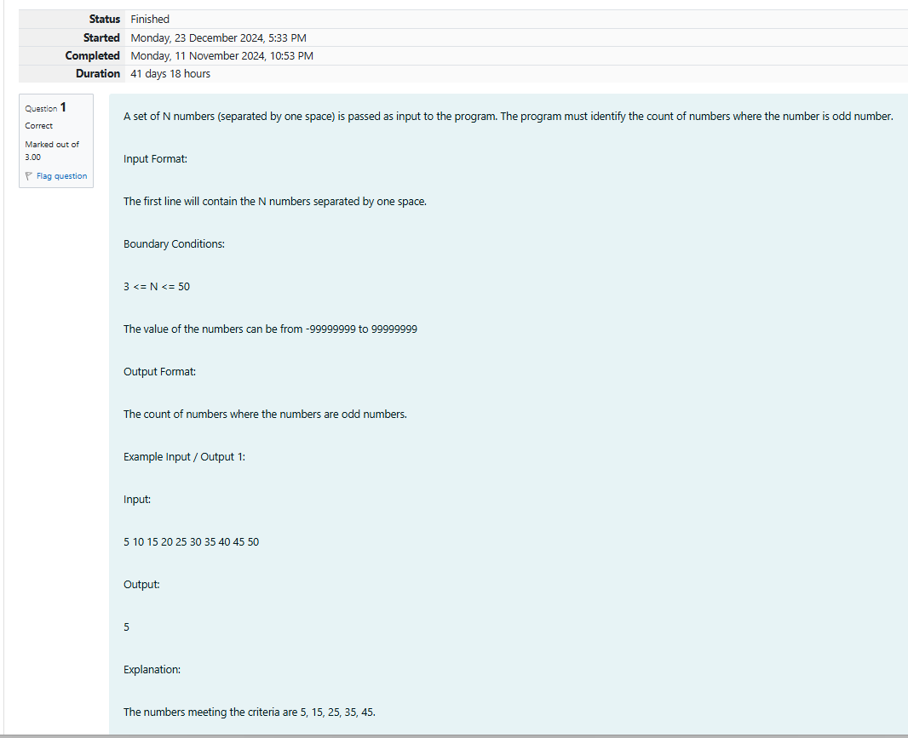

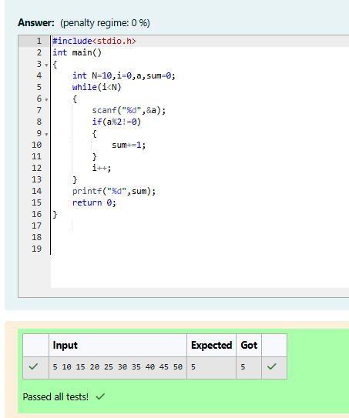

Week 04-02-practice session coding

Reg no : 241801291

Name : TARRUN.B

Q2)

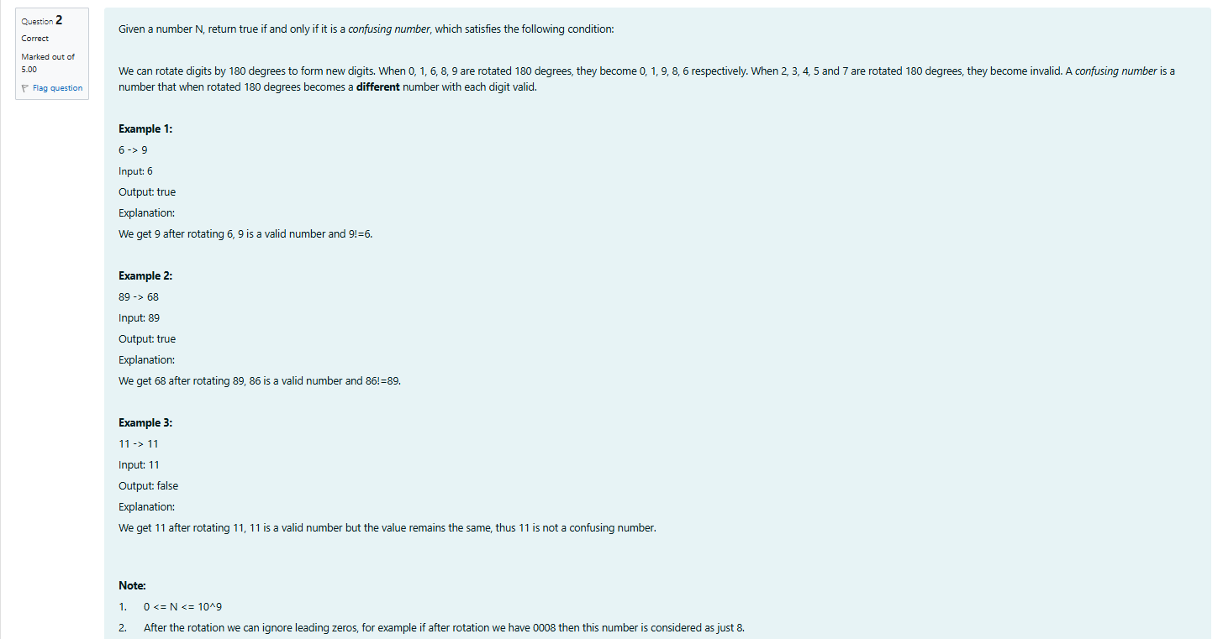

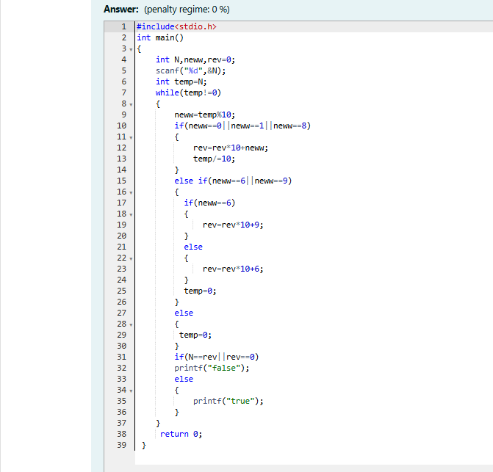

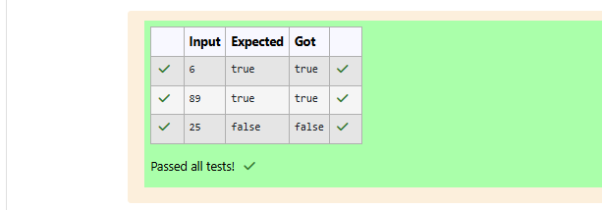

Week 04-02-practice session coding

Reg no : 241801291

Name : TARRUN.B

Q3)

